JAVA PROJECT REPORT
(Project Term January-May 2023)

Money Mate:

The Futuristic Currency Converter for your Desktop

Submitted by

SANCHIT CHOPRA
Registration Number :12113343

Course Code: CSE310

Under the Guidance of

(Dr. Ranjith Kumar)

School of Computer Science and Engineering


DECLARATION

We hereby declare that the project work entitled (“Currency Calculator”) is an authentic record of our own work carried out as requirements of Capstone Project for the award of BTech degree in CSE from Lovely Professional University, Phagwara, under the guidance of (Dr. Ranjith Kumar). All the information furnished in this capstone project report is based on our own intensive work and is genuine.

Name of Student: Sanchit Chopra
Registration Number: 12113343

(Sanchit Chopra)
Date:18th April 17, 2023

TABLE OF CONTENTS
Inner first page………………………………………………………………………. (i)
Declaration…...……………………………………………………………………...(ii)
Table of Contents……………………...……………………………………………(iii)

1. Introduction…………………………………………………….………...………..(1)
1.1 Scope of the project………………………..…………………………….(2)
1.2 Modules………………………………...……………………………..... (2)
2. Sample codes………………………………………….……………………...…...(3)
3. Outcome of the project…….;………………………………………………...…...(4)

1. INTRODUCTION
Currency Converter is a powerful tool that provides an easy and accurate way to calculate exchange rates between different currencies. To use a currency converter, simply enter the amount of money you want to convert and the currency you want to convert it to. The currency converter will then display the equivalent amount in the other currency.
A currency converter is a tool that allows you to convert between different currencies quickly and easily. It is a handy tool for travellers, businesses, and anyone else who needs to know the value of one currency in terms of another.
There are many different currency converters available online and on mobile devices. Some are free to use, while others charge a fee. Most currency converters use real-time exchange rates, so you can be sure that you are getting the most up-to-date information.
To use a currency converter, simply enter the amount of money you want to convert and the currency you want to convert it to. The converter will then display the equivalent amount in the other currency.
Currency converters can be a valuable tool for anyone who needs to know the value of one currency in terms of another. They are quick and easy to use, and they provide up-to-date exchange rates.
Here are some of the benefits of using a currency converter:
- Convenience: Currency converters are available online and on mobile devices, so you can use them anywhere.
- Accuracy: Most currency converters use real-time exchange rates, so you can be sure that you are getting the most up-to-date information.
- Ease of use: Currency converters are very easy to use. Simply enter the amount of money you want to convert and the currency you want to convert it to. The converter will then display the equivalent amount in the other currency.

1.1. SCOPE OF THE PROJECT

Currency converter helps international import and export businesses by helping them determine the selling and buying profits of different products. Currency conversion is also useful for forex traders, offering the ability to track changes in exchange rate valuations in real time.

Currency converters aim to maintain real-time information on current market or bank exchange rates, so that the calculated result changes whenever the value of either of the component currencies do. The do sob connecting to a database of current currency exchange rates.


1.2. MODULES
3.1 (WELCOME MODULE)

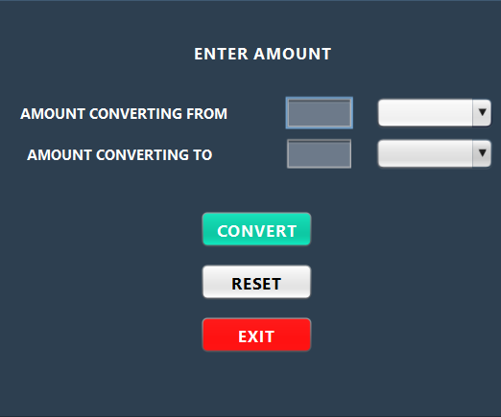

3.2 (MAIN CONVERSION MODULE)
2. SAMPLE CODES
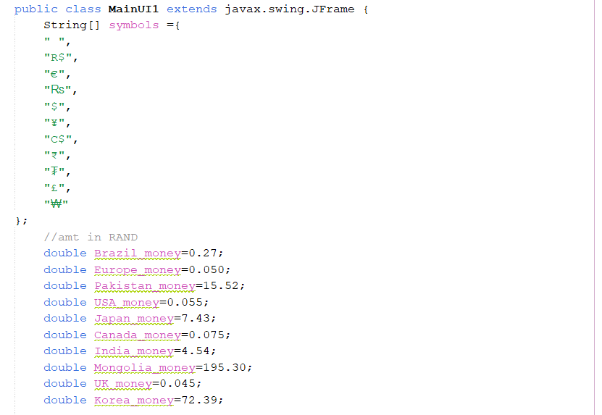
4.1 (ARRAY FOR THE LIST)

4.2 (MAKING SELECTION OF THE COUNTRIES)
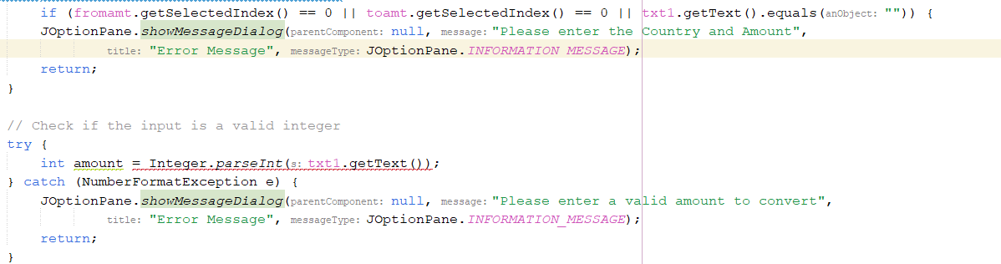

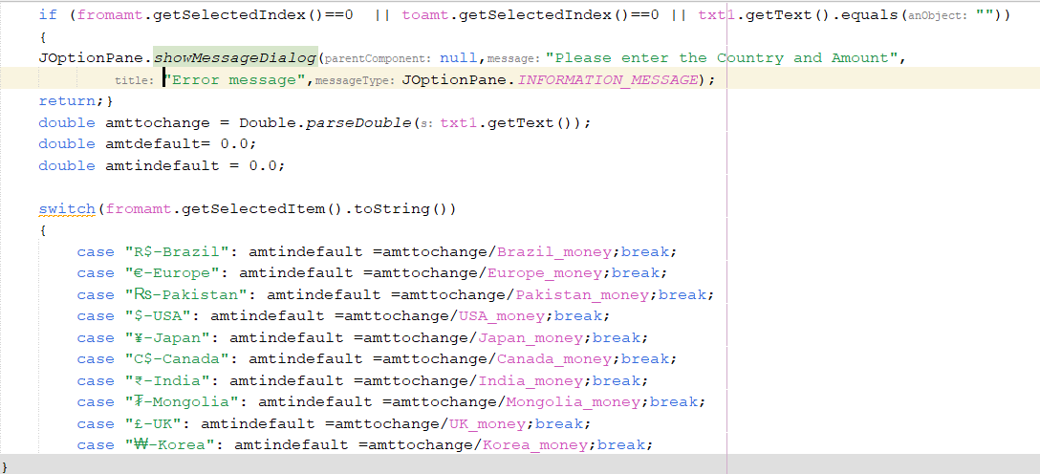

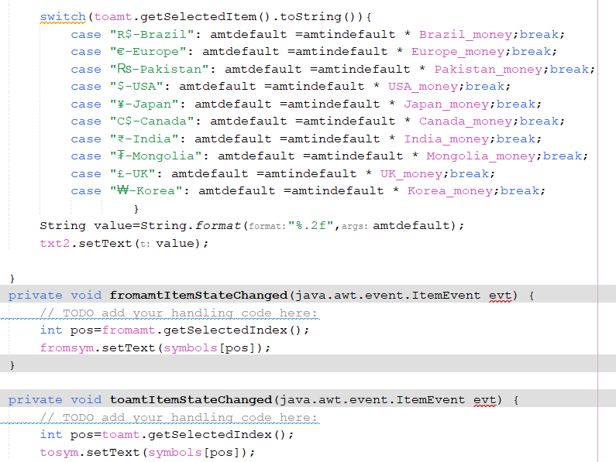

3.Outcome of the Project
The outcome of using a currency converter can be a few things. It can help you:
Plan a trip abroad: When you are planning a trip abroad, it's important to know how much your money will be worth in the local currency. A currency converter can help you do this by giving you up-to-date exchange rates.
- Send money to another country: If you need to send money to another country, a currency converter can help you calculate the cost of the transfer.
- Track the value of your investments: If you have investments in foreign currencies, a currency converter can help you track the value of your investments in real time.
- Compare exchange rates: When you are looking for the best exchange rate, it's important to compare rates from different providers. A currency converter can help you do this by providing you with a list of exchange rates from different providers.

